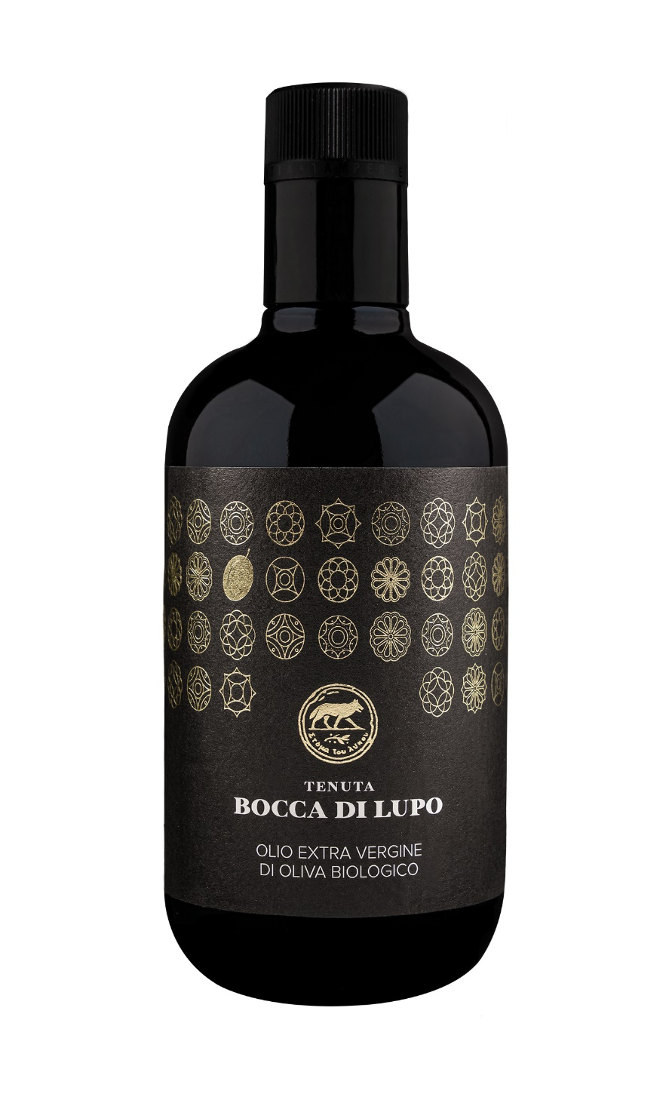
TENUTA BOCCA DI LUPO ORGANIC EXTRA VIRGIN OLIVE OIL
Classification
Organic Extra Virgin Olive Oil
Vintage
2024
Olive variety
Coratina
Climate
The 2024 growing season saw mild winter weather and limited rainfall. Spring remained dry, prompting early flowering that occurred about two weeks ahead of time. As drought conditions persisted, it was essential to provide irrigation to ensure proper vegetative growth of the olive trees and development of the drupes.
The olive harvest took place during the first half of October, well ahead of the estate’s seasonal averages. The olives were hand harvested then milled just a few hours later to best preserve the fruit’s characteristics and quality.

Place of Origin
All olives are sourced from Tenuta Bocca di Lupo in Minervino Murge (BT) located at an altitude of approximately 300 meters above sea level (984 feet) in the heart of the Murge area. All olives are indigenous Apulian varieties that have existed for centuries in this harsh rugged territory that can be challenging yet at the same time generous offering the highest quality fruit. The olive trees are an average of 80 years old and are vase trained. All olive groves are managed following organic farming principles.

Tasting notes
Tenuta Bocca di Lupo’s organic extra virgin olive oil is a bright yellow-green color. The nose presents fresh notes of tomato leaves, wild chicory and almonds. The palate is pleasantly persistent with good balance between piquant and bitter notes, typical characteristics of the Coratina olive variety.

