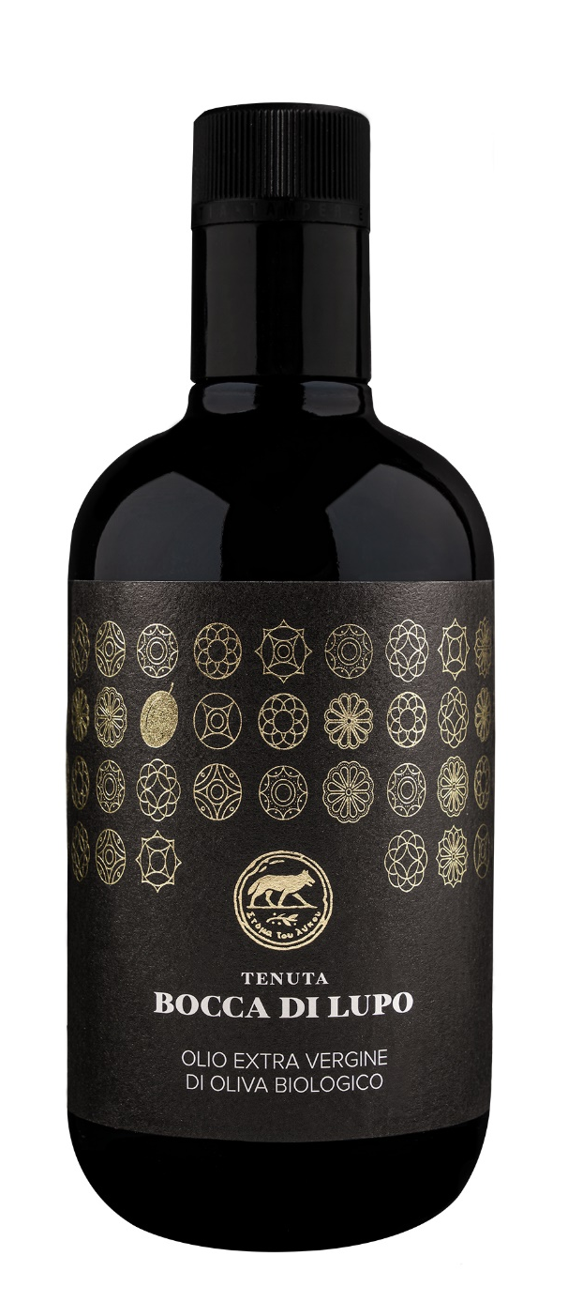
TENUTA BOCCA DI LUPO ORGANIC EXTRA VIRGIN OLIVE OIL
Classification
Organic Extra Virgin Olive Oil
Vintage
2025
Olive variety
Coratina
Climate
The 2025 growing season was characterized by a relatively mild winter and a spring marked by good rainfall, particularly between March and April, ensuring excellent water reserves and optimal support for vegetative growth.
From late June through the end of September, weather conditions were defined by above-average temperatures and a dry climate. Despite the water reserves accumulated during spring, it was necessary to support production with measured irrigation interventions, allowing for regular and uniform growth and development of the drupes.
The olives were hand harvested during the first ten days of October, slightly earlier than usual, and milled just a few hours after harvest in order to best preserve the fruit’s quality.

Place of Origin
All olives are sourced from Tenuta Bocca di Lupo in Minervino Murge (BT) located at an altitude of approximately 300 meters above sea level (984 feet) in the heart of the Murge area. All olives are indigenous Apulian varieties that have existed for centuries in this harsh rugged territory that can be challenging yet at the same time generous offering the highest quality fruit. The olive trees are an average of 80 years old and are vase trained. All olive groves are managed following organic farming principles.

Tasting notes
Tenuta Bocca di Lupo’s organic extra virgin olive oil is bright yellow with green highlights. On the nose, it reveals notes of artichoke and fresh almond.
On the palate, it is well-structured and balanced, with the distinctive spicy note typical of the Coratina variety.

