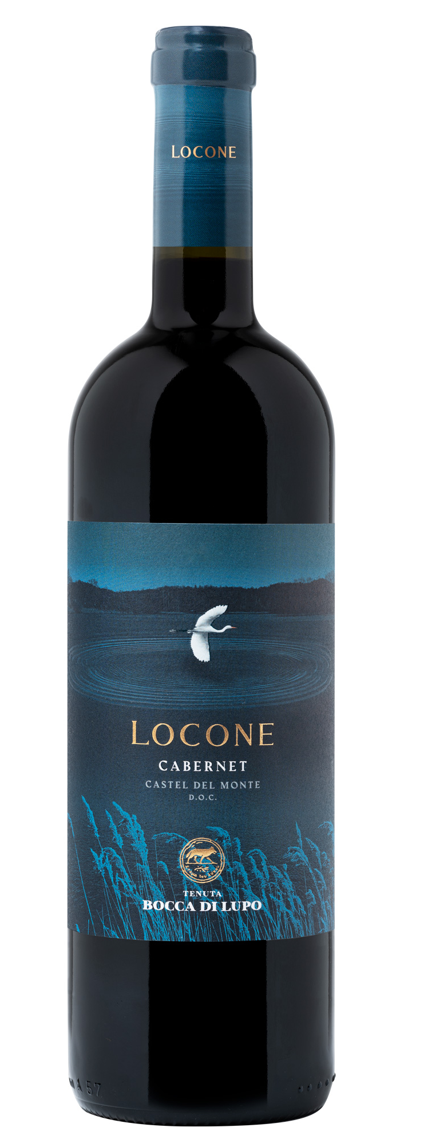
LOCONE
Classification
Cabernet Castel del Monte D.O.C. – Certified Organic Wine
Vintage
2022
Grape variety
Cabernet
Climate
The 2022 growing season saw dry weather during the winter months and sunny hot conditions in spring and summer that persisted until mid-August. Cabernet vines began budbreak mid-April, consistent with last year’s timeline, while rising temperatures mid-May accelerated shoot growth and flowering which took place towards the end of the month. Targeted irrigation management allowed the vines to achieve good balance and produce full, well-balanced clusters. At harvest time, the fruit was in optimal conditions, whole firm and perfectly ripe. The grape harvest for Locone took place during the last half of September.
Vinification and aging
Harvested grapes were brought to the cellar, destemmed and delicately crushed. The must was transferred into fermentation vats where alcoholic fermentation took place at a controlled temperature of 26-28 °C (79-82 °F). Maceration on the skins lasted for a period of approximately ten days performing punch-downs and pump-overs for a balanced and gradual extraction of color, aroma, and body. Once alcoholic fermentation was complete, the wine was transferred into oak barriques when malolactic fermentation took place and Locone was left to age.

Alcohol content
14.5% by Vol.

Historical data
Tenuta Bocca di Lupo is located at an altitude of 250 meters above sea level (820 feet) in the heart of the rugged Murgia area near Minervino Murge about 90 kilometers west of Bari. All of the estate’s vineyards are certified organic and are located on calcareous and low-nutrient soils that are excellent for producing the finest quality red wines and superb white wines. The main grape varieties grown are Chardonnay, Fiano, Aglianico, Nero di Troia, Cabernet Sauvignon, Cabernet Franc and Moscato di Trani.
The name Locone comes from a lake in the Minervino Murge region, an artificial reservoir that has the same name. Over the years, this area has become a beautiful fresh water habitat attracting a wide diversity of flora and fauna, fundamental in creating a pristine, karstic and essential landscape, typical of the Murgia area.

Tasting notes
Locone 2022 is lively ruby red in color. Intense aromas on the nose of currants and wild berries accompany pleasant balsamic notes of Mediterranean scrub and wild arugula. The bouquet is completed by delicate and subtle notes of roasted coffee and cocoa. The palate is fresh, supple with soft silky tannins. Locone is inviting and enjoyable and closes with a finish that echoes the savory characteristics typical of the soils in this area.

