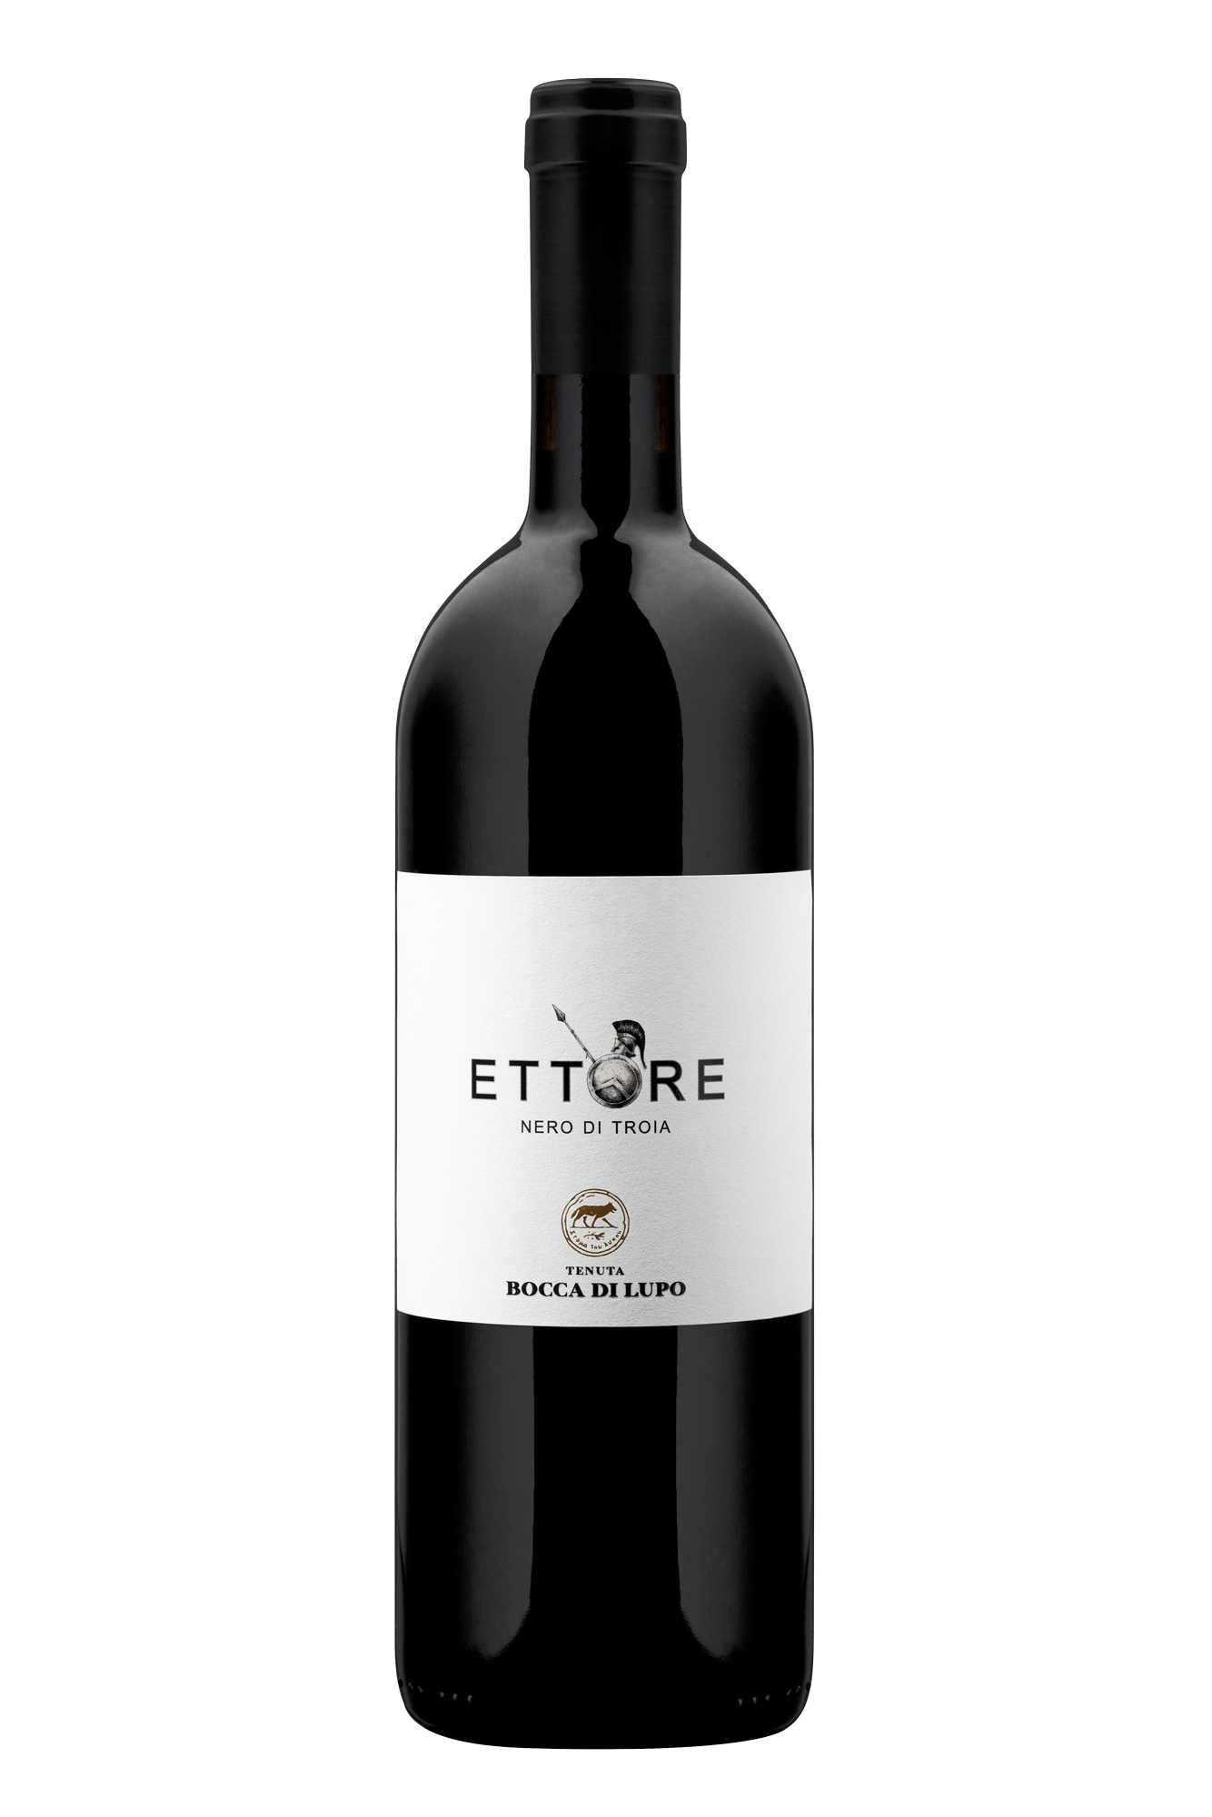
ETTORE

Classification
Nero di Troia D.O.C. Castel del Monte - Certified Organic Wine

Vintage
2021
Grape variety
Nero di Troia
Climate
The 2021 growing season was defined by hot temperatures and particularly dry weather. A sudden drop in temperatures during the first half of April resulted in a delay in budburst but did not compromise vine vigor. Higher temperatures during spring boosted shoot growth and allowed the vines’ physiological processes to catch up to a normal pace in the growing season, consequently bringing phenological stages back to seasonal averages on the estate. Summer brought significant drought conditions with hot temperatures and was accompanied by optimal temperature swings between day and night and targeted irrigation.
Dry conditions during the month of September persisted up until the grape harvest, which began at the beginning of October. These conditions were optimal for picking perfectly ripe, firm and crisp fruit.

Vinification and aging
The grapes were carefully selected in the vineyard, brought to the cellar, destemmed, and gently crushed. Maceration on the skins took place in stainless steel vats at a controlled temperature of 28 °C (82 °F). During this phase, delicate punch downs and délestage were carried out for a gradual and gentle extraction over a period of approximately ten days. After racking, the wine was transferred directly into oak barriques where malolactic fermentation took place, and the wine was left to age. Ettore was further aged in the bottle for an extended period before being released for sale.

Alcohol content
13.5% by Vol.

Historical data
Ettore is produced on Tenuta Bocca di Lupo, located at an altitude of 250 meters above sea level (820 feet) in the heart of the rugged Murgia area near Minervino Murge about 90 kilometers west of Bari. All of the estate’s vineyards are certified organic and are located on calcareous and low-nutrient soils that are excellent for producing the finest quality red wines and superb white wines. The main grape varieties grown are Chardonnay, Fiano, Aglianico, Nero di Troia, Cabernet Sauvignon, Cabernet Franc and Moscato di Trani.

Tasting notes
Ettore is ruby red in color with purple hues. The nose offers fresh aromas of mixed berries and blueberries that meet balsamic and spicy notes of laurel, juniper and licorice. The palate is well-balanced with decisive and pleasantly lively tannins, typical of this ancient grape variety, with outstanding freshness and sapidity. Ettore 2021 can be enjoyed immediately but also has excellent aging potential.

