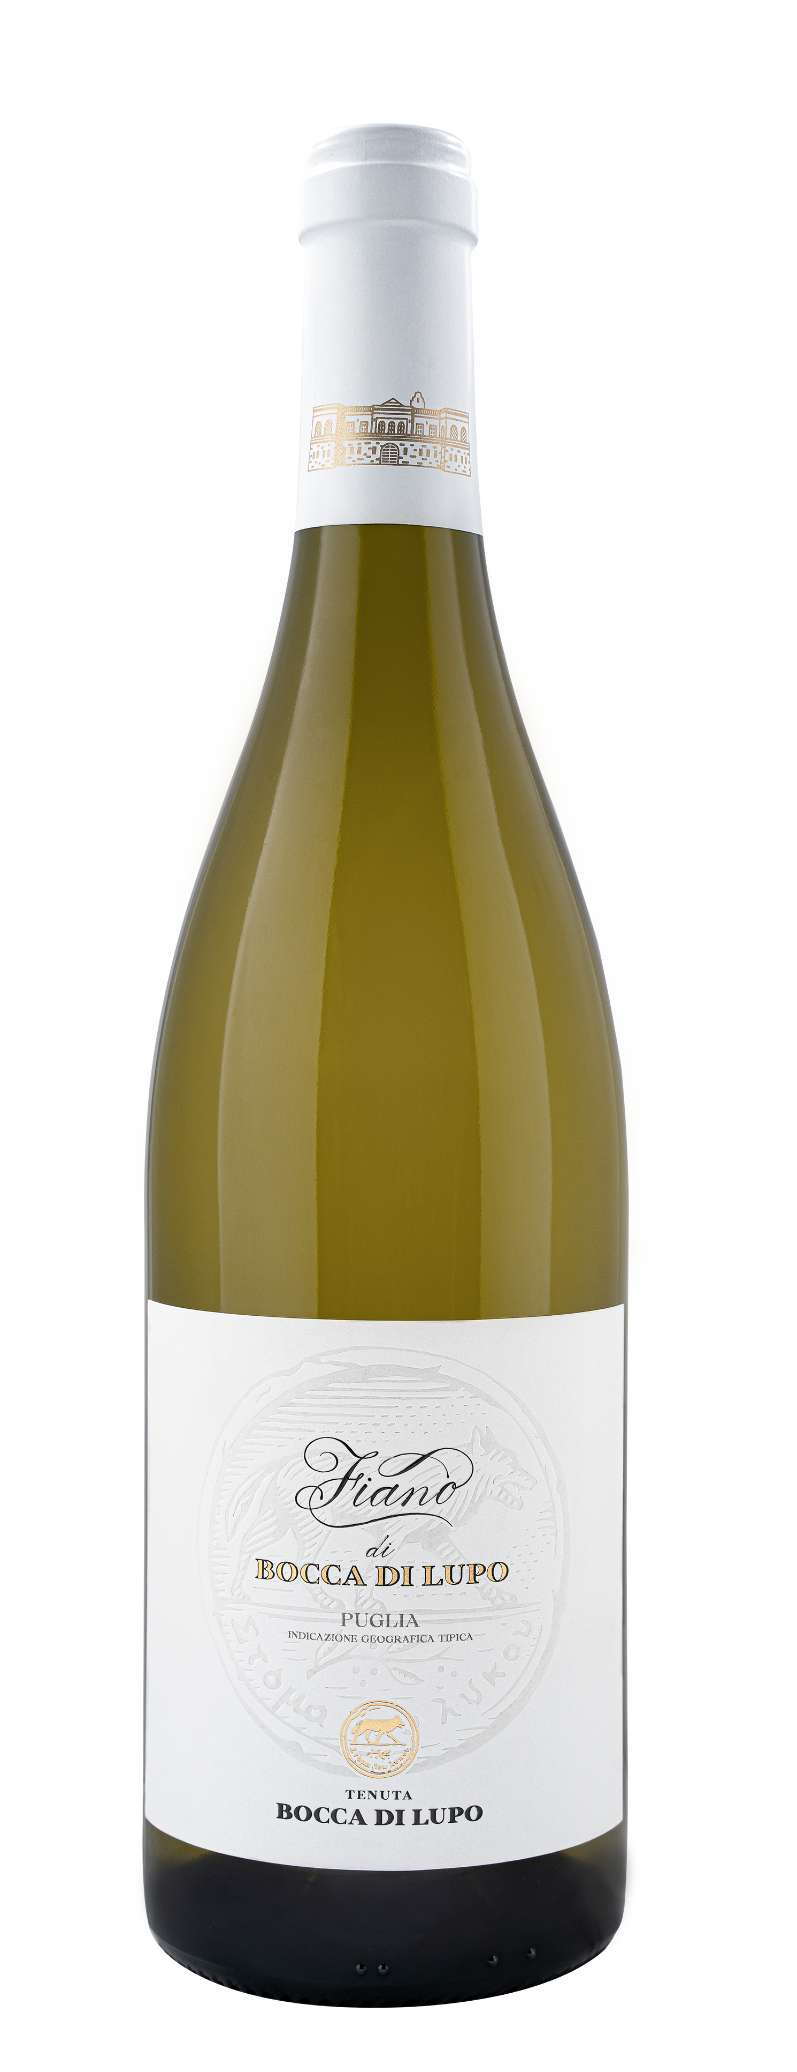
FIANO DI BOCCA DI LUPO

Classification
Fiano IGT Puglia – Certified Organic Wine

Vintage
2023

Grape variety
Fiano

Climate
The 2023 growing season began with mild winter weather that caused the vines to break dormancy about one week earlier than seasonal averages. Cool temperatures in spring, especially in April and May, led to gradual shoot growth and slowed down flowering and fruit set. Regular rain showers from the end of April to mid-June brought good groundwater reserves to vineyard soils, an essential resource to face the upcoming months. The second half of summer up until harvest time saw high temperatures and drought conditions. These climatic conditions ensured that grape clusters achieved excellent phenolic and aromatic maturity while preserving whole, healthy berries. The grape harvest took place on September 13th, picking only the finest berries from estate vineyards.

Vinification and aging
Freshly harvested grapes were destemmed and delicately pressed. The free run juice was chilled to 10 °C (50 °F) for 24/48 hours to favor natural clarification. The must was then transferred to stainless steel vats for alcoholic fermentation that was completed in French oak tonneaux and continued to age on the lees. After barrel aging for several months, Fiano di Bocca di Lupo was prepared for bottling. The wine underwent an additional period of aging in the bottle before being released.

Alcohol content
12.5% by Vol.

Historical data
Tenuta Bocca di Lupo is located at an altitude of 250 meters above sea level (820 feet) in the heart of the untamed Murgia area near Minervino Murge about 90 kilometers west of Bari. All the estate’s vineyards are certified organic and grow in calcareous and low-nutrient soils that are excellent for producing the finest quality red wines and superb white wines. The main grape varieties grown are Chardonnay, Fiano, Aglianico, Nero di Troia, Cabernet Sauvignon, Cabernet Franc and Moscato di Trani.
Fiano di Bocca di Lupo was crafted from the finest selection of Fiano grapes grown on the estate in Minervino Murge, a name that comes from the area where it is produced.

Tasting notes
Fiano di Bocca di Lupo 2023 is straw yellow with greenish hues. On the nose, notes of pears, white melon and grapefruits accompany fresh floral hints and delicate balsamic impressions of arugula and sage. The bouquet is completed by subtle aromas of vanilla, roasted hazelnuts, and white tea. The palate is lively with excellent freshness, structure and mineral notes that are characteristic of Tenuta Bocca di Lupo’s soils. A wine with a fascinating identity that can be enjoyed immediately but can also be appreciated in the years to come.

