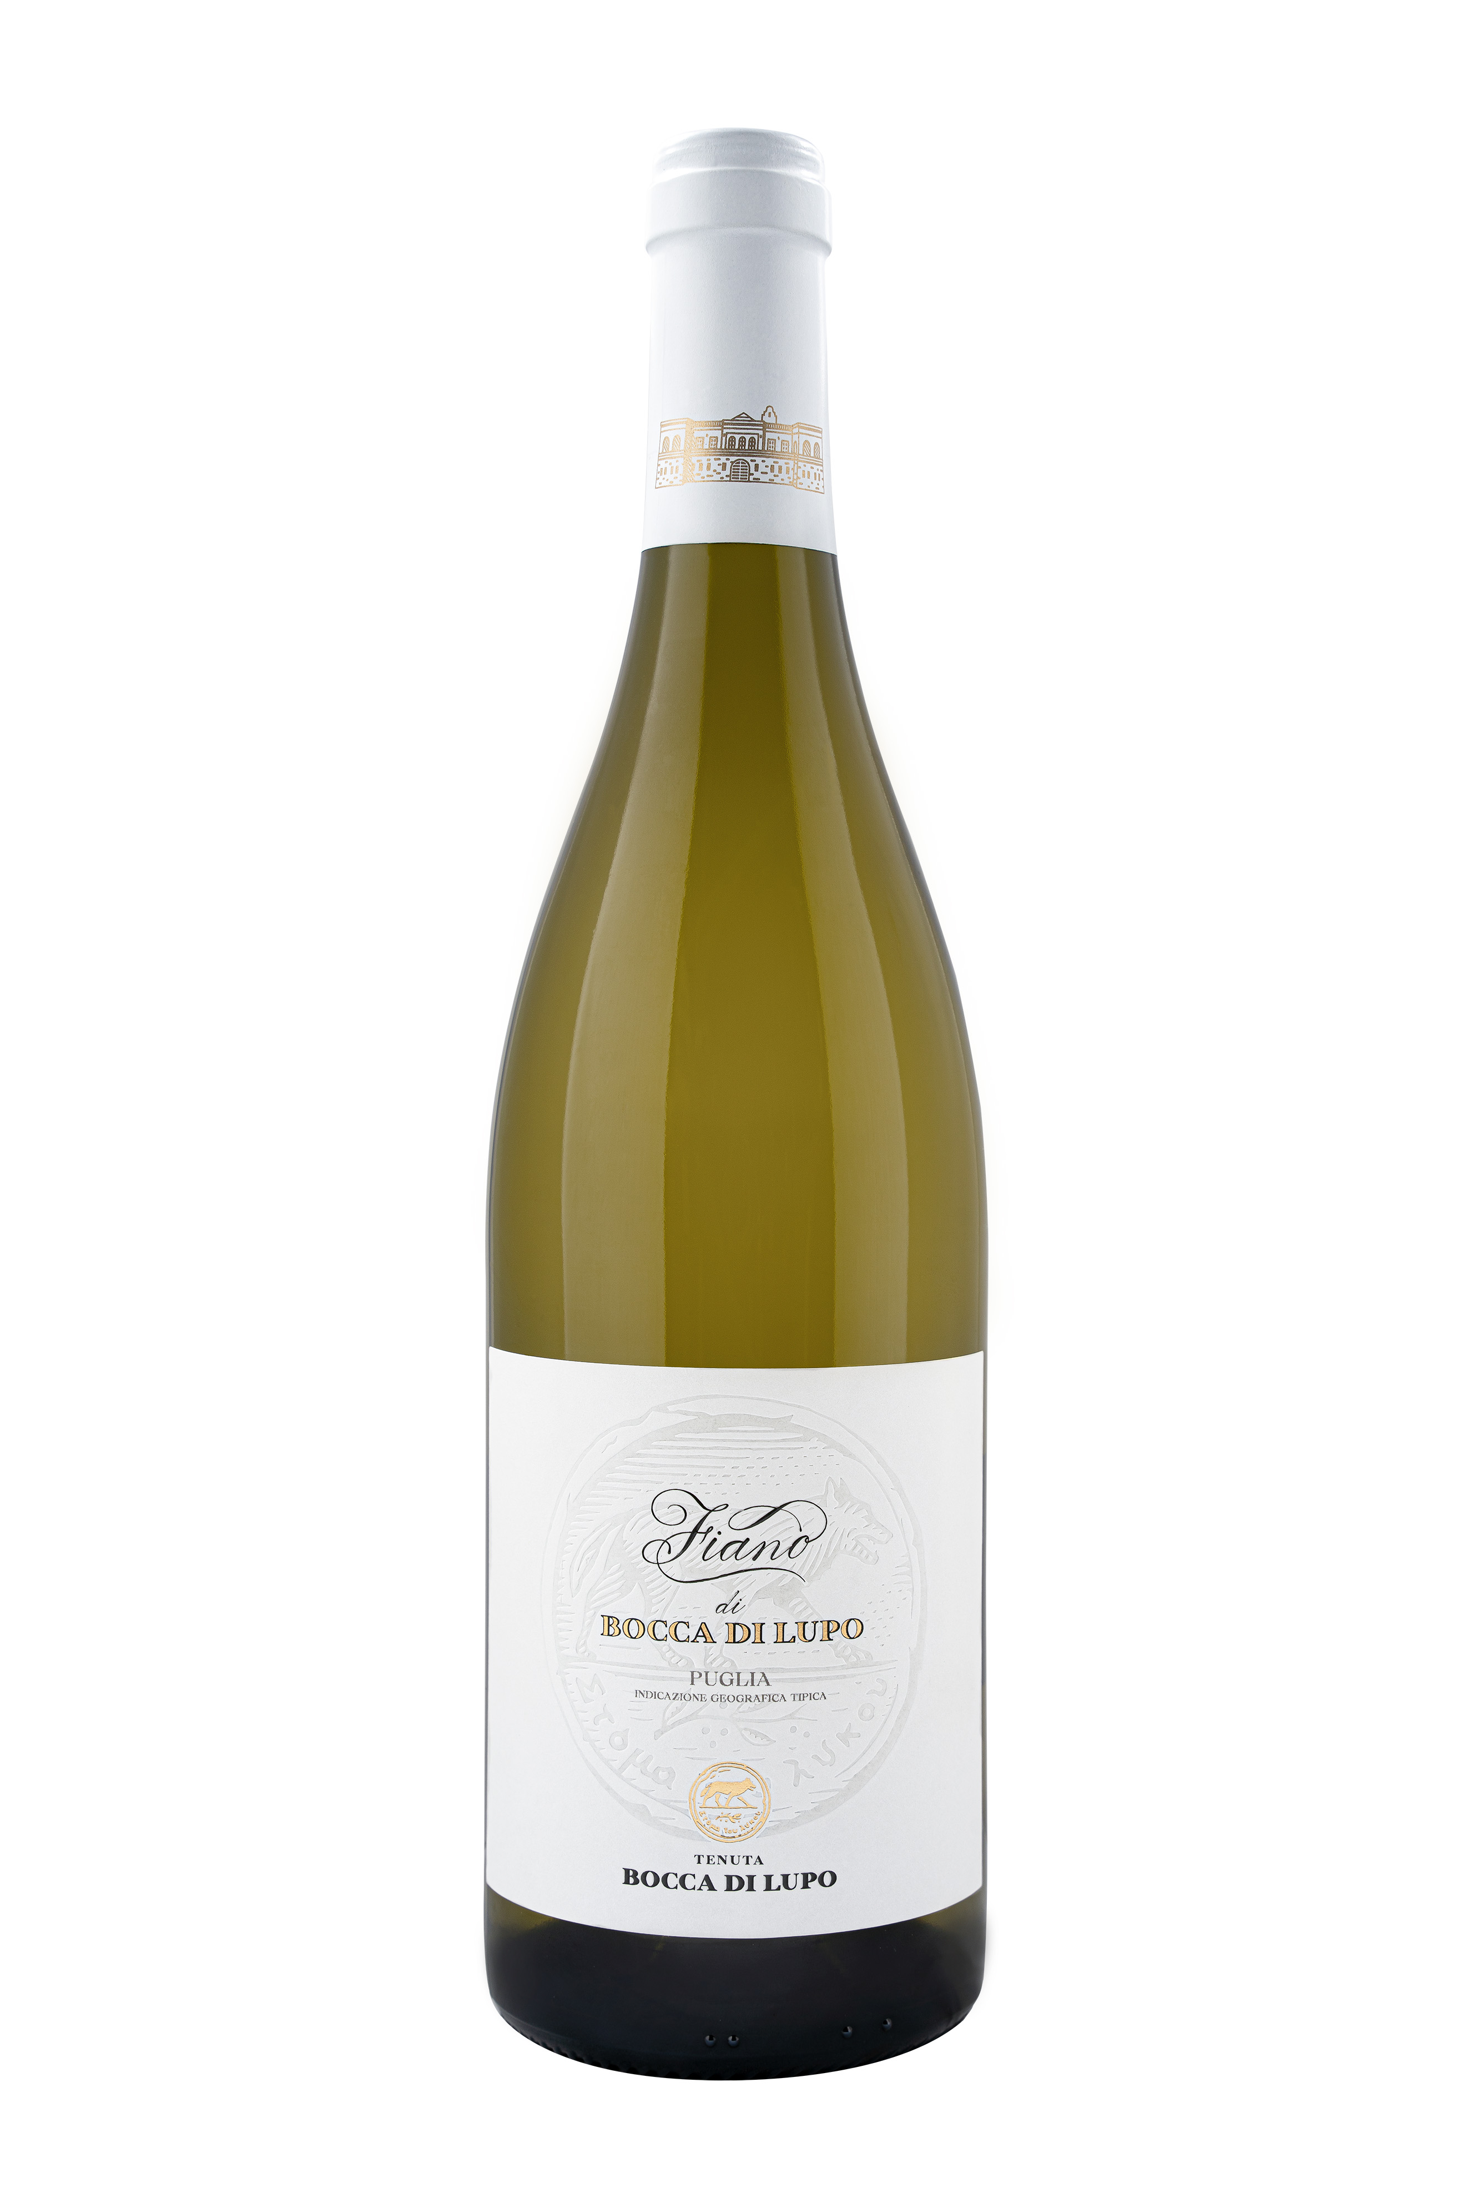
FIANO DI BOCCA DI LUPO

Classification
Fiano IGT Puglia – Certified Organic Wine

Vintage
2024

Grape variety
Fiano

Climate
Mild winter weather and very little rainfall marked the beginning of the 2024 growing season, these conditions prompted budbreak at the end of March, two weeks earlier than seasonal averages. The last half of April brought a drop in temperatures that offset the early start to the season and slowed down vine growth. Spring and summer weather trends were defined by a significant and extended period of drought however, targeted irrigation and canopy management for strategic shading avoided vine stress and guaranteed optimal cluster growth. The months preceding the grape harvest were dry with high temperatures resulting in an early harvest, which was completed towards the end of August. Harvested fruit was perfectly healthy, at peak ripeness with outstanding freshness. As in the past, the harvest took place at night to protect the grapes from elevated daytime temperatures and to avoid potential oxidation.

Vinification and aging
Freshly harvested grapes were destemmed and delicately pressed. The free run juice was chilled to 10 °C (50 °F) for 24/48 hours to facilitate natural clarification. The must was then transferred to stainless steel vats for the onset of alcoholic fermentation that was completed in French oak tonneaux where it continued to age on the lees. After aging in oak for several months, Fiano di Bocca di Lupo was prepared for bottling. The wine underwent an additional period of aging in the bottle before being released.

Alcohol content
12% by Vol.

Historical data
Tenuta Bocca di Lupo is located at an altitude of 250 meters above sea level (820 feet) in the heart of the untamed Murgia area near Minervino Murge about 90 kilometers west of Bari. All the estate’s vineyards are certified organic and grow in calcareous and low-nutrient soils that are excellent for producing the finest quality red wines and superb white wines. The main grape varieties grown are Chardonnay, Fiano, Aglianico, Nero di Troia, Cabernet Sauvignon, Cabernet Franc and Moscato di Trani.
Fiano di Bocca di Lupo was crafted from the finest selection of Fiano grapes grown on the estate in Minervino Murge, a name that comes from the area where it is produced.

Tasting notes
Fiano di Bocca di Lupo 2024 is bright yellow with light green hues. The nose delivers floral notes of acacia and linden flowers together with delicate hints of orange zest and grapefruits. The bouquet is completed by notes of vanilla and white tea. The palate is fresh and vertical defined by mineral notes characteristic of Bocca di Lupo’s soils. A wine with a fascinating identity that can be enjoyed immediately but can also be appreciated in the years to come.

