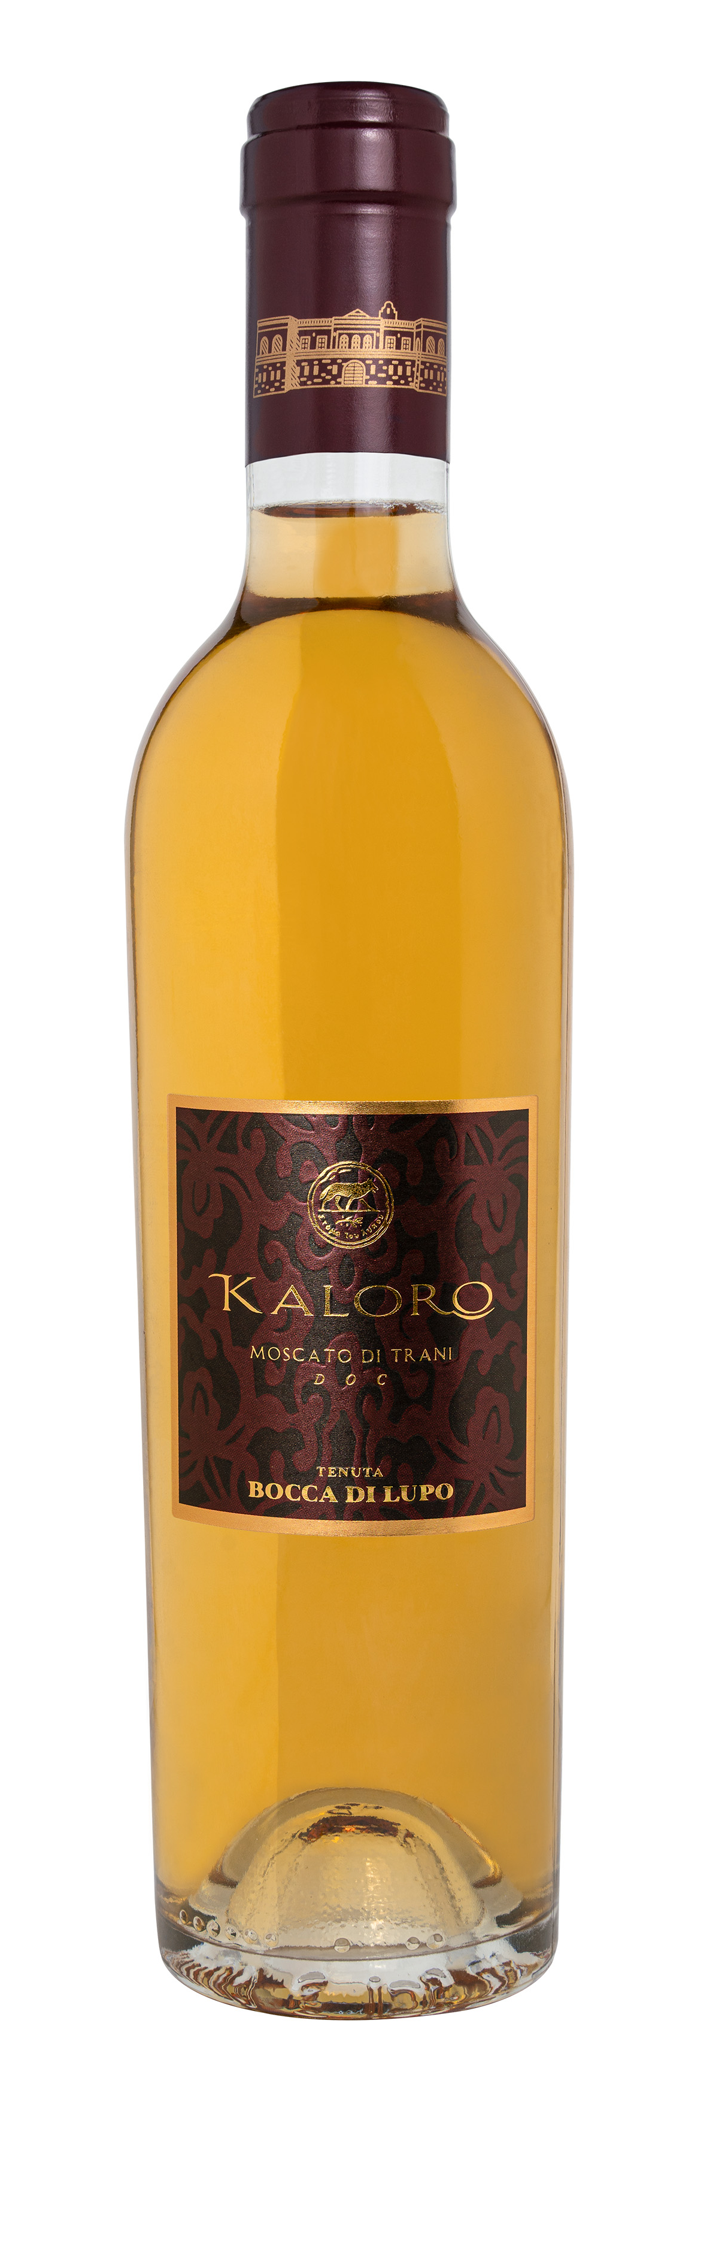
KALORO

Classification
Moscato di Trani D.O.C. – Organic Wine

Vintage
2023

Grape variety
Moscato Reale

Climate
The 2023 growing season began with mild winter weather that caused the vines to break dormancy about one week earlier than seasonal averages. Cool temperatures in spring, especially in April and May, led to gradual shoot growth and slowed down flowering and fruit set. Regular rain showers from the end of April to mid-June brought good groundwater reserves to vineyard soils, an essential resource to face the upcoming months. The second half of summer up until harvest time saw high temperatures and drought conditions. These climatic conditions ensured that grape clusters achieved excellent phenolic and aromatic maturity while preserving whole, healthy berries. Harvesting activities of Moscato Reale grapes for Kaloro began at the end of August, the fruit presented pure clean flavors and a good aromatic expression.

Vinification and aging
Moscato Reale clusters were hand harvested and placed on mats, then stacked in special racks or crates and placed in the sun. This natural drying process, which lasted for approximately 20 days, allowed for the natural concentration of sugars, aromatic compounds, and freshness. After drying in the sun, the grapes were gently pressed and the free run juice was clarified by cold settling then transferred to stainless steel tanks where alcoholic fermentation took place in at a controlled temperature between 14 and 16 °C (57 and 61 °F), to best enhance the grape variety’s aromatic potential. The wine was aged in stainless steel and an additional period in the bottle.

Alcohol content
10.5% by Vol.

Historical data
Tenuta Bocca di Lupo is located at an altitude of 250 meters above sea level (820 feet) in the heart of the untamed Murgia, an area near Minervino Murge about 90 kilometers west of Bari. The calcareous and low nutrient soils are ideal for producing the finest quality red wines and superb white wines. The estate has 130 hectares (321 acres) of vineyards that are entirely certified organic. The main grape varieties grown are Chardonnay, Fiano, Aglianico, Nero di Troia, Cabernet Sauvignon, Cabernet Franc and Moscato di Trani.
The name “Kaloro” was inspired by the pleasantly warm climate of Apulia and the golden colors of its landscape bathed in sunlight. Moscato is one of the most appreciated grape varieties in Apulia due to its natural sweetness and its characteristic aroma lending itself to the production of captivating white wines with golden hues. Its freshness and pronounced acidity make it unique in the array of southern Italian sweet wines.

Tasting notes
Kaloro 2023 is golden yellow in color. The nose offers rich notes of orange blossom honey, acacia, and hints of candied fruit. Inviting aromas typical of southern Italy are accompanied by a perfect balance between freshness and Moscato’s varietal aromas. The palate is silky, dense, with a natural residual sugar content sustained by pleasant acidity. A versatile wine to serve at the end of a meal that pairs perfectly with sweet or savory.

