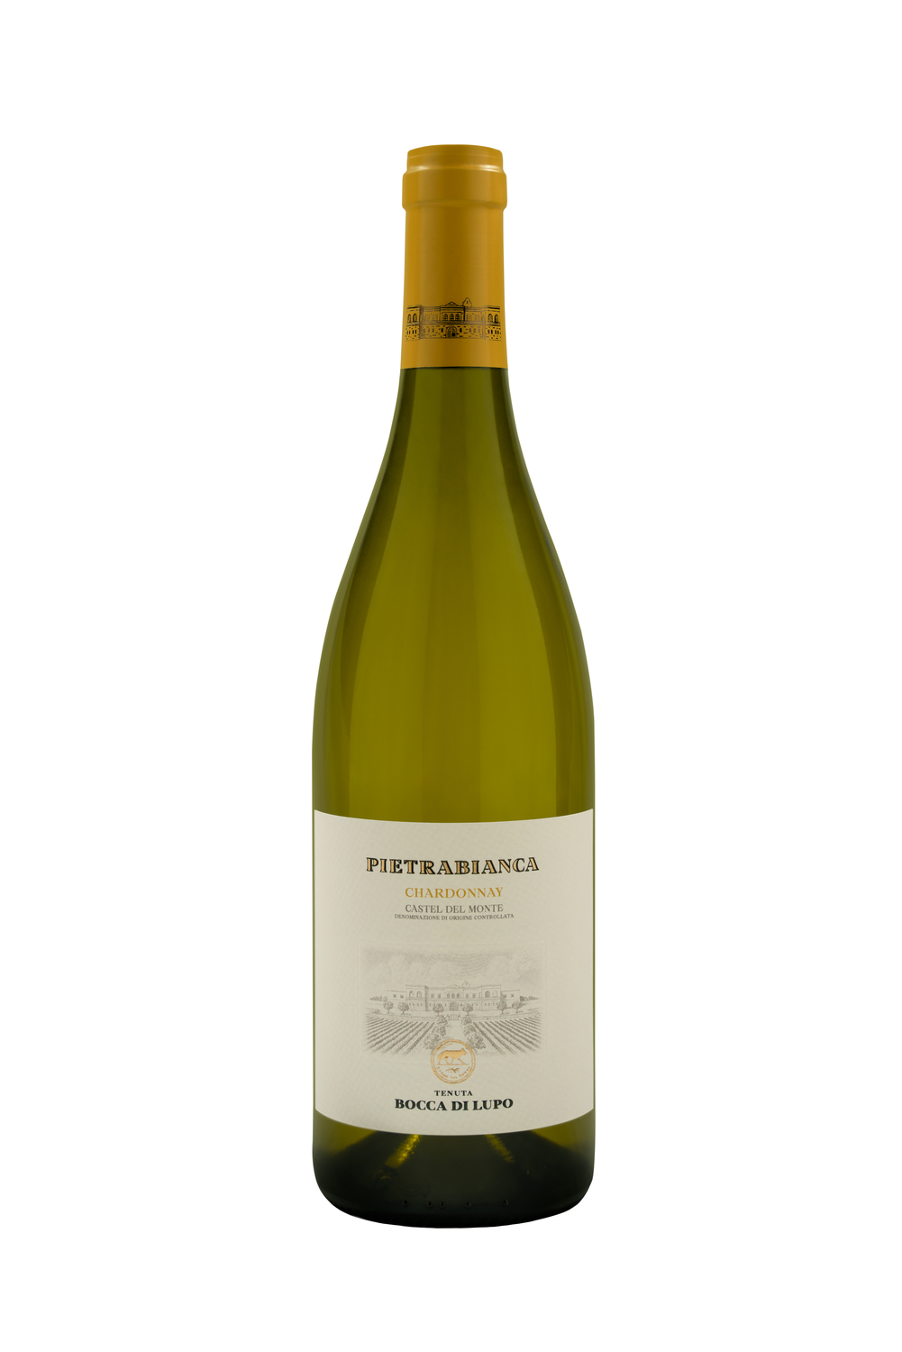
PIETRABIANCA
Classification
Chardonnay Castel del Monte D.O.C. – Organic wine
Vintage
2023
Grape variety
Chardonnay, Fiano
Climate
The 2023 growing season began with mild winter weather that caused the vines to break dormancy about one week earlier than seasonal averages. Cool temperatures in spring, especially in April and May, led to gradual shoot growth and slowed down flowering and fruit set. Regular rain showers from the end of April to mid-June brought good groundwater reserves to vineyard soils, an essential resource to face the upcoming months. The second half of summer up until harvest time saw high temperatures and drought conditions. These climatic conditions ensured that grape clusters achieved excellent phenolic and aromatic maturity while preserving whole, healthy berries. The 2023 grape harvest began mid-August, in line with the estate’s seasonal averages, with Chardonnay while Fiano was picked during the first half of September.

Vinification and aging
Grapes were harvested in the early morning hours to preserve fresh aromas and avoid oxidation during higher daytime temperatures. After destemming, the grapes were gently crushed, and the must was transferred into stainless steel tanks at a temperature of approximately 10 °C (50 °F) to favor natural clarification. Part of the Chardonnay must was then transferred into French oak barriques where alcoholic fermentation took place, followed by malolactic fermentation and aging on the lees. Fiano grapes, and the remaining Chardonnay grapes, were fermented in stainless steel tanks at a controlled temperature of 16-18 °C (61-64 °F) to enhance the grape varieties’ characteristic freshness. In January, the Chardonnay aged in barriques was transferred to stainless steel tanks, blended with Fiano and the other part of Chardonnay, then bottled several months later. The wine underwent an additional period of aging in the bottle before being released.

Alcohol content
12.5% by Vol.

Historical data
The Bocca di Lupo estate is located at an altitude of 250 meters above sea level (820 feet) in the heart of the untamed Murgia area near Minervino Murge about 90 kilometers west of Bari. The estate’s certified organic vineyards grow on calcareous, low nutrient soils that are optimal for producing the finest quality red wines and superb white wines. The main grape varieties grown are: Chardonnay, Fiano, Aglianico, Nero di Troia, Cabernet Sauvignon, Cabernet Franc and Moscato di Trani. Pietrabianca is an elegant Chardonnay, with a small percentage of the indigenous Fiano grape variety, crafted at the Bocca di Lupo estate in the heart of Apulia’s Murgia area, and its name was inspired by the territory. “Pietrabianca” refers to the stones that rural farmers hit while ploughing the fields and, once they were crushed and ground into the soil, helped enhance the aromas and flavors of the wines grown here.

Tasting notes
Pietrabianca 2023 is bright yellow with greenish hues. The nose offers notes of white pulp fruit with hints of cantaloupes, oranges, and limes together with delicate floral notes of hawthorn and acacia. The bouquet is completed by lively hints of vanilla and white chocolate. The palate is delicate, but never heavy, with excellent freshness and structure. The wine closes with pleasant mineral notes typical of the soils on Tenuta Bocca di Lupo. Pietrabianca has great character and a unique identity and can be enjoyed immediately but can also be appreciated in the years to come.

