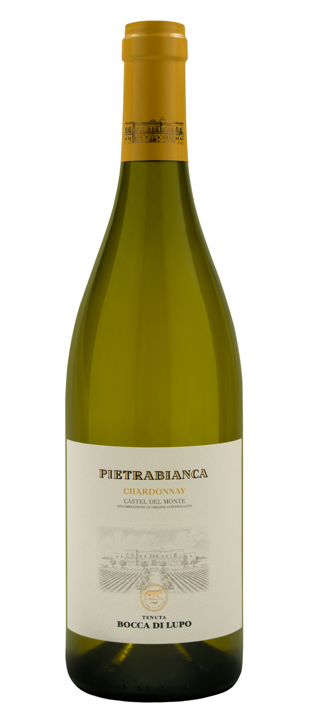
PIETRABIANCA
Classification
Chardonnay Castel del Monte D.O.C. – Organic wine
Vintage
2024
Grape variety
Chardonnay, Fiano
Climate
Mild winter weather and limited precipitation defined the beginning of the 2024 growing season. These climatic conditions caused the buds to emerge from dormancy about two weeks earlier than seasonal averages, starting from March 10th. The month of April brought cool temperatures while spring and summer ushered in an extended period of sunny weather with very limited rainfall. Under these climatic conditions, precision irrigation techniques were essential to ensure proper growth and development of grape clusters, which were perfectly healthy and ripe at harvest time. Harvesting activities got underway earlier than usual, Chardonnay was harvested at the very beginning of August and Fiano was picked ten days later.

Vinification and aging
Grapes were harvested at night to preserve fresh aromas and avoid oxidation during higher daytime temperatures. After destemming, the grapes were gently crushed, and the must was transferred into stainless steel tanks at a temperature of approximately 10 °C (50 °F) to favor natural clarification. Part of the Chardonnay must was then transferred into French oak barriques where alcoholic fermentation took place, followed by malolactic fermentation and aging on the lees. Fiano grapes, and the remaining Chardonnay grapes, were fermented in stainless steel tanks at a controlled temperature of 16-18 °C (61-64 °F) to enhance the grape varieties’ characteristic freshness. In January, the Chardonnay aged in barriques was transferred to stainless steel tanks, blended with Fiano and the other part of Chardonnay, then bottled several months later. The wine underwent an additional period of aging in the bottle before being released.

Alcohol content
12.5% by Vol.

Historical data
The Bocca di Lupo estate is located at an altitude of 250 meters above sea level (820 feet) in the heart of the untamed Murgia area near Minervino Murge about 90 kilometers west of Bari. The estate’s certified organic vineyards grow on calcareous, low nutrient soils that are optimal for producing the finest quality red wines and superb white wines. The main grape varieties grown are: Chardonnay, Fiano, Aglianico, Nero di Troia, Cabernet Sauvignon, Cabernet Franc and Moscato di Trani. Pietrabianca is an elegant Chardonnay, with a small percentage of the indigenous Fiano grape variety, crafted at the Bocca di Lupo estate in the heart of Apulia’s Murgia area, and its name was inspired by the territory. “Pietrabianca” refers to the stones that rural farmers hit while ploughing the fields and, once they were crushed and ground into the soil, helped enhance the aromas and flavors of the wines grown here.

Tasting notes
Pietrabianca 2024 is straw yellow in color with light green hues. The nose is intense with notes of white pulp fruit and orange blossoms that lead over to fresh balsamic hints of mint, arugula and aromatic herbs. A delicate note of vanilla enhances the aromatic profile and completes the bouquet. The palate presents outstanding freshness and complexity. The wine closes with pleasant mineral notes typical of the soils on Tenuta Bocca di Lupo. Pietrabianca has great character and a unique identity and can be enjoyed immediately but can also be appreciated in the years to come.

